Game-Theory-Based Balance: Formalizing the Machine Unlearning Problem as a Game Between Model Provider and Data Provider

PhD Proposal Submitted to

By
Abhishek Hupele
Research Scholar-240900465
School of Computer Engineering,
Manipal Institute of Technology, Manipal

Under the Supervision of
Dr. Sanjay Singh
Professor (Guide)
School of Computer Engineering,
Manipal Institute of Technology, Manipal

Dr. P.C. Siddalingaswamy
Associate Dean (Co-Guide)
School of Computer Engineering,
Manipal Institute of Technology, Manipal

Dr. Naveen Kulkarni (Co-Guide)
Director – Product Engineering - AI
Edgeverve Systems Limited

March 2026

Table of Contents
Table of Contents 2
List of Figures 4
List of Tables 5
Glossary 6
1.Introduction 7
1.1 Introduction to Machine Unlearning 7
1.2 Introduction to Game Theory 10
1.3 Intersection of Game Theory and Privacy 12
1.4 Problems Identified 14
1.5 Proposed Solutions 17
2.Literature Review 20
3.Research Gaps 24
4.Objectives 25
5.Methodology 26
5.1 Overall Methodology 26
5.2 Objective Specific Methodology 31
5.2.1 Objective-1 31
5.2.2 Objective-2 32
5.2.3 Objective-3 35
6.Expected Outcome 37
7.Importance of Proposed Research 37
8.Research Time Plan 38
9.Pilot study 39
9.1 Pilot Study: Part 1 (Machine Unlearning) 39
9.2 Pilot Study: Part 2 (Membership Inference via Backdooring) 45
9.3 Pilot Study: Part 3 (Game Theory) 46
10.Details of Expenses and Source of Funding 48
11.Course Work Details 48
2.Similarity Check Report 49
13. References 50

List of Figures
1 | Machine Unlearning Approaches | ………………………….. | 9
2 | Illustration of Machine Unlearning | ………………………….. | 10
3 | MUL-GT Strategy Profile Space | ………………………….. | 14
4 | MUL-GT Strategy Space Flow Diagram | ………………………….. | 19
5 | Block Diagram of the Overall Methodology | ………………………….. | 30
6 | Feature Level Machine Unlearning | ………………………….. | 31
7 | Game-Theoretic Unlearning under Different Attack Models | ………………………….. | 32
8 | MUL GT Space for MIA via Backdoor | ………………………….. | 34
9 | Data Ecosystem Based Flow | ………………………….. | 36
10 | SISA Training Architecture | ………………………….. | 40
11 | Accuracy vs Requests | ………………………….. | 42
12 | Retraining Time vs Requests | ………………………….. | 43
13 | Retraining Time vs Requests vs Accuracy | ………………………….. | 44
14 | The Simplified Class Diagram of MLPro-GT-NA | ………………………….. | 47

List of Tables
1 | Literature Survey Machine Unlearning and Game Theory | ……………... | 20
2 | Mapping of Research Objectives to Research Gaps | ……………... | 25
3 | Research Plan Schedule | ……………... | 38
4 | Course Work Details Suggested by DAC with Credits | ……………... | 48

Glossary
AI | : | Artificial Intelligence
CNN | : | Convolution Neural Network
DNN | : | Deep Neural Network
LLM | : | Large Language Model
LSTM | : | Long Short Term Memory
MIA | : | Membership Inference Attack
ML | : | Machine Learning
MUL | : | Machine Unlearning
NPTEL | : | National Programme on Technology Enhanced Learning
PCA | : | Principal Component Analysis
PII | : | Personally Identifiable Information
RAI | : | Responsible AI
RNN | : | Recurrent Neural Network
SISA | : | Sharded, Isolated, Sliced, Aggregated
SVM | : | Support Vector Machine

1.Introduction
The development in Artificial Intelligence (AI), and the progress in Generative AI has parallelly raised concern for responsible use of the Data in these technologies. Data is back bone of the technology and Machine Learning (ML) and numerous cases of misuse and use of data without users consent at international level have come to light in last decade itself.
Concepts such as ethical AI, algorithmic accountability, responsible research have been discussed in research area since long back, further in mid 2010’s term “Responsible AI” [1] was coined and started being used by governance as well as academia as an umbrella term encompassing ethical, secure , fair, transparent, privacy-preserving, accountability principles in AI and ML.
Machine Unlearning is a key pillar of Responsible AI [2][3]. Let’s understand What is Machine Unlearning ?

Introduction to Machine Unlearning
Machine Unlearning as institutive from term ‘Machine’ and ‘Unlearning’, means making machine unlearn or forget something which it has learned or acquired knowledge of, so that the machine behaves in same way as it would without having knowledge of the data in the first place.
Now, someone may ask why was machine fed with the data in the first place if it needs to be removed or unlearned at later stage. There could be multiple reason for unlearning the specific training data from machine learning models [2][3], like
- Data owner withdraws consent at later stage
- Data owner consent was not received itself
- Unethical practices used for data acquisition
- Identification of Adversarial Training Data
- Copyright Data
- Data no-longer relevant
- Legal and Compliance requirements
Now, when data needs to be unlearned, deleting the data from some storage is not sufficient, if the data is used for training machine learning model, it needs to be removed from the model. The challenge lies here as some ML models like Deep Neural Networks (DNN), Large Language are complex , are black box and exact contribution of data is hard to ascertain, particularly because of following in training [3]
- Stochasticity
- Incrementality
- Catastrophe of Unlearning
Machine Unlearning refers to such techniques and algorithms which facilitates forgetting of the data, the four main areas are [3]:
- Centralized Unlearning
- Federated (Distributed) Unlearning
- Unlearning Verification
- Privacy and Security Issues in Machine Unlearning

Figure 1 : Machine Unlearning Approaches [2]
Figure 1 depicts the 4 main approaches of machine unlearning [2].
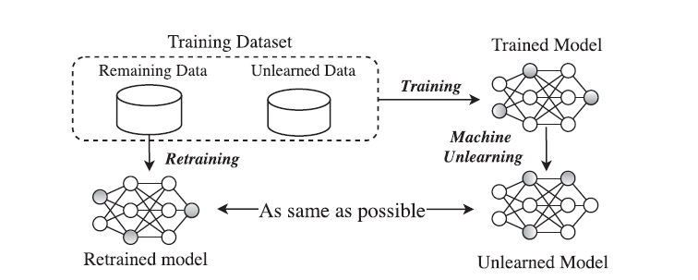
Figure 2 : Illustration of Machine Unlearning [3]
Figure 2 illustrates an example of machine unlearning for a trained model. Showing that retrained model and unlearned model are intended to be as same as possible.

Introduction to Game Theory
Game theory is a mature area of research which has been researched extensively, it’s root lies in mathematics and economics, it helps us to understand and study strategic outcomes between players which are decision-makers in certain real-world scenario as a game setting. It provides mechanism to analyse and predict the behaviour of entities, how entities respond and make decision. Which in turn helps to devise optimal strategies and predict outcomes in real-world scenarios [4][5].
Here are some key concepts to understand game theory [4]:
- Players: The individuals, groups, or entities making decisions in the "game."
- Strategies: The complete plan of action that a player will take in any given situation.
- Payoffs: The outcomes or rewards that each player receives based on the combination of strategies chosen by all players. These are often represented numerically, reflecting utility or preference.
- Information: The knowledge each player has about the game, including the rules, the other players' possible strategies, and their potential payoffs. Games can have perfect or imperfect information.
- Equilibrium: A stable state in a game where no player has an incentive to unilaterally change their strategy, given the strategies of the other players. The most famous concept of equilibrium is the Nash Equilibrium, where each player's strategy is the best response to the strategies chosen by all other players.
How it works:
Game theory models real-world situations as "games" to predict and explain behavior under conditions of competition and cooperation. It helps us understand how individuals or groups make decisions when their interests are interdependent. By laying out the possible actions, their consequences, and the preferences of the players, game theory helps to identify optimal strategies and predict likely outcomes [4].
Classifications of Game Theory Models
- Cooperative vs. Non-Cooperative Games:
- Static (Simultaneous) vs. Dynamic (Sequential) Games:
- Complete vs. Incomplete Information:
- Zero-Sum vs. Non-Zero-Sum Games:
- Symmetric vs. Asymmetric Games:
Key Game Theory Models and Concepts
- Prisoner's Dilemma:
- Nash Equilibrium:
- Battle of the Sexes:
- Chicken Game (Hawk-Dove Game):
- Cournot Competition:
- Stackelberg Competition:
- Ultimatum Game:
Applications of Game Theory
Game theory is applied across a vast range of disciplines:
- Economics: Market competition (oligopolies, auctions), bargaining, labor economics, public goods.
- Political Science: Voting behavior, coalition formation, international relations, arms races, diplomatic negotiations.
- Biology: Evolutionary stable strategies, animal behavior, predator-prey dynamics.
- Computer Science/AI: Algorithm design, network routing, multi-agent systems, cybersecurity, blockchain.
- Business Strategy: Pricing decisions, market entry, advertising campaigns, mergers and acquisitions.
- Social Sciences: Social dilemmas, cooperation, trust, social networks.
By providing a structured way to analyze strategic interactions, game theory offers powerful insights into decision-making in complex environments.

Intersection of Game Theory and Privacy
Game theory has become a booming field in privacy-preserving techniques over the past decade. Numerous schemes leveraging game theory exist to navigate the trade-off between data privacy and utility. For example, game theory has been used to model the adoption of hybrid encrypted cloud data deduplication (H-DEDU) [6], formulating interactions between data holders, data owners, and Cloud Storage Providers (CSPs) as a multi-stage Stackelberg game to find optimal strategies. It has also been applied to personalized differential privacy to balance privacy levels and data utility by modelling user-adversary confrontations as static Bayesian games.
In the context of machine unlearning, this intersection is particularly pertinent. For a model provider, machine unlearning inherently presents a trade-off between model performance and user privacy. An "over-unlearning" strategy, where too much information is removed or removed too aggressively, can lead to performance degradation, rendering the model less effective. Conversely, "insufficient protection" might result in privacy leaks, as the unlearning process may not fully erase the sensitive data's influence [7]. The crucial open question is whether the unlearning problem can be formalized as a game between two players: a model provider and a data provider. Such a game model could define strategies and utilities for both entities, leading to unlearning operations that optimally balance model performance with the protection of users' sensitive data from being leaked. This research proposal aims to address these critical, unaddressed issues.
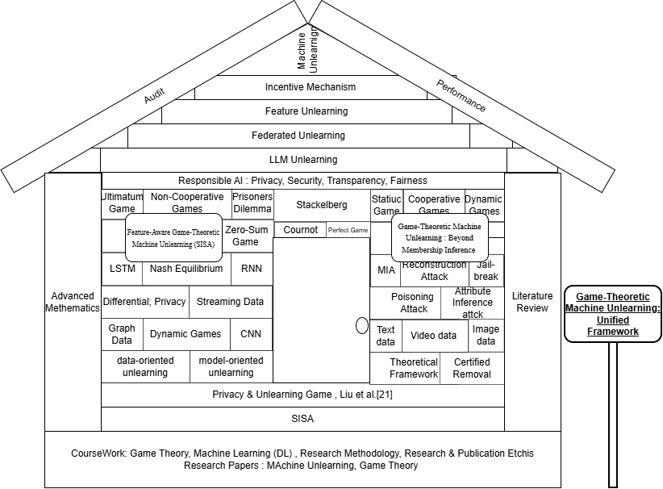
Figure 3 MUL-GT Strategy Profile Space
Figure 1.3 shows that in Machine Unlearning there could be many different attributes like models, dataset, utility, game theory framework’s, harmful agents, various unlearning settings (federated, sequential , dynamic etc.) it shows landscape of potential game theory opportunities to be explored. Let’s call it MUL-GT strategy profile space.

Problems Identified
Personally Identifiable Information (PII) is a treasure trove, highly relevant and not easily available, which has lead to violations of privacy and personal data is used without consent, which in turn has led people more exposed and vulnerable. Several cases like Cambridge Analytica [8], Apple Card Gender Bias [9], Amazon Hiring Algorithm [10] , Clearview AI Facial Recognition [11], Target Pregnancy Prediction [12], Cross-Border GenAI Misuse (Predicted by Gartner) [13] have come into light which violated the PII norms and deviate from Responsible AI principles.
This has led governments worldwide to pass legislations for an individuals “Right to be Forgotten”[1][2], there by necessitating large corporations compliance. Notable laws are the GDPR in the European Union [14] , the PIPEDA privacy legislation in Canada [15], Digital Personal Data Protection Act in 2023 by India [16] and the California Consumer Privacy Act in the United States [17].

Some of the identified problems are:
Data as a Double-Edged Sword, it is two edge sword , if all or majority of people in the world choose to refrain from allowing any type of their data to be used, than we as a society and individual will not be able to reap benefits of all the technological advancement that can be possible. For example, your medical data can be used to train for disease prediction like cancer or ecommerce recommendation engine helps you to locate desired product from millions of choices by showing relevant results, or may be as a recruiter you get help from AI to shortlist relevant candidates from thousands of applications, these are only few of the examples.
Basically, technology should be used for making your life easier, save your time, do things efficiently which needs data to stay relevant in many cases, so as I said its two edge sword, lack of data will make AI models irrelevant in certain critical scenarios and on the other hand exposing data may harm individually financially , mentally.
So there needs to be balance, and safe guards for data privacy, and choice to the individuals giving control over how and what data of theirs is used.
Need for Balance: Privacy, Consent, and Individual Control, removing the data already used to train complex models like DL, ML and LLMs, is highly difficult for reasons like randomness, catastrophe effect [2], complex algorithm. And it is not always easy to find the contribution of particular data point.
Technical Difficulty of Removing Data from Trained Models, Guarantee of Removal, if some model provider claims that particular data has been removed, the verification of that claim is also a challenge called certified removal [8].
No Universal Machine-Unlearning; Diverse Threats and Scenarios, there are so many algorithms , scenarios, models in the play and there is no generalized machine unlearning algorithm that fits for all. There are data providers , model providers than there are malicious players which use Membership Inference Attacks (MIA) [18], Jailbreak etc. To give different scenarios like for example: Federated settings there are multiple agents, Feature Based Unlearning, Outcome could be bias.
Performance Degradation and Information Leakage Risks, removing data leads to decline in model performance, also the difference in output of old and new unlearned model can be used to obtain information on data [1][2].
Variability in Models and Deployment Scenarios, In AI and ML , multiple permutation and combination exists for ml (architecture) models, data modalities, unlearning requests can come in different forms, multiple adversary models , domain specific techniques.
So covering all the variations for unlearning is also challenge , there is lack of universal or generalized frameworks.
Unlearning requests can be sequential , streaming requests, feature level. Also, Multiple model algorithms like Random Forest, SVM, PCA, Decision trees etc.. categorized as classical ML algorithms, than there are Neural Network architecture based algorithms like CNN, LSTM, RNN, DNN and lastly transformer architecture based LLMs, BERT, XLNET,….. exist. Many Data modalities text, image, graph, video, audio etc exists. Also many Adversary threats like membership inference attack [18], inversion attack, … exists. There could be unlearning techniques varying for particular domain like financial, medical etc..

Proposed Solutions
To overcome the above identified problems or challenges, Machine Unlearning for Addressing the Challenge of Incorrectly Learned Information has come out as prominent solution, further considering the large number of attributes as explained in last section, proposing Formalizing the Machine Unlearning Problem as a Game Between Model Provider and Data Provider, it involves exploring and solutioning machine unlearning for different models focusing on classical and Neural Networks ML models in initial research and extending the learnings to other architectures like transformers at later stage. Also, we will like to focus on fewer data modalities in the beginning like text, image and after substantial progress is achieved, we would like to expand our research to include other data modalities, ml models, attack models, federated settings, dynamic unlearning, streaming unlearning requests.
Further, I would like to propose designing a generalized game theory based framework for machine unlearning which can serve as verified reference and guide for practitioners in the field of machine unlearning.
Currently, we would like to keep a flexible approach in research and not like to define constraint’s in terms of scope of research, as outcome is supposed to be generalized for multiple scenarios, we hope that as we get involved more in actual research, it will help in defining the path more clearly.
That said, we also acknowledge that the scope can be overwhelming , so we will gradually increase the scope of the research extending it further for generalizing.
Now, we saw the MUL-GT Strategy Space Profile in Figure 3, below in Figure 4 is shown the flow diagram of the strategy space that we will navigate in our objectives, it will help in expressing the scope of existing study as well as give idea on the possible extension that can be explored further.
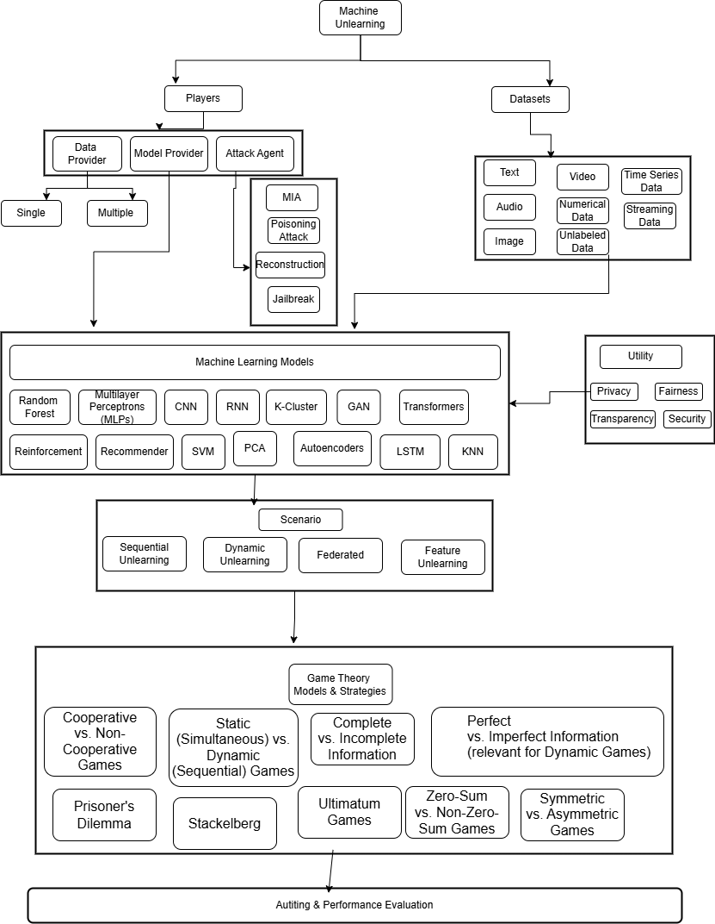
Figure 4 : MUL-GT Strategy Space Flow Diagram

2.Literature Review
Table 1: Literature Survey Machine Unlearning and Game Theory
Sl No | Title | Authors | Year | Methodology | Result | Limitations
1 | Machine Unlearning [20] | Lucas Bourtoule; Varun Chandrasekaran; Christopher A. Choquette-Choo; Hengrui Jia; Adelin Travers; Baiwu Zhang; David Lie; Nicolas Papernot | 2020 | SISA training (sharding + slicing; analytical + empirical evaluation) | Retraining speedups: Purchase 4.63×, SVHN 2.45×, ImageNet 1.36× (with accuracy trade-offs) | Accuracy trade-off ; Requires additional storage;  Performance gains diminish if unlearning requests exceed ~3× number of shards; Not all data is useful, core-set selection
2 | Membership Inference via Backdooring [18] | Hongsheng Hu; Zoran Salcic; Gillian Dobbie; Jinjun Chen; Lichao Sun; Xuyun Zhang | 2022 | data owners mark a tiny fraction of their samples with imperceptible backdoor triggers; perform black-box queries and statistical hypothesis testing (t-test) to detect backdoored models; empirical evaluation on CIFAR-10, Location-30, Purchase-100. | Effective with minimal marking and queries: marking ≈0.1% of training data and ~30 queries suffices; | Requires owners to pre-mark data; assumes adversary includes marked samples in training; trigger size/location trade-offs; may be detectable or ethically sensitive; effectiveness varies by dataset/model generalization.
3 | Game-Theoretic Machine Unlearning: Mitigating Extra Privacy Leakage [21] | Hengzhu Liu; Tianqing Zhu; Lefeng Zhang; Ping Xiong | 2024 | Game-theoretic unlearning: Stackelberg game between an unlearning module (minimizes model distance + classification error using an alternativ e model and third-party data) and a privacy module (minimizes attacker advantage via a membership attack model); theoretical bounds + empirical evaluation. | Produces unlearned models close to retrained ones while reducing privacy attack advantage; provides theoretical upper bound on attacker advantage and demonstrates effectiveness on real datasets. | Depends on alternative/third-party data and attacker model assumptions; potential utility–privacy trade-offs; added computation and requirement that defender has white-box access to tune modules.
4 | MLPro-GT - game theory and dynamic games modeling in Python [4] | Steve Yuwono; Detlef Arend; Andreas Schw | 2024 | Software engineering / framework paper: design and implementation of MLPro-GT (MLPro submodule) with MLPro-GT-NA (native GT) and MLPro-GT-DG (dynamic GT); class diagrams, templates  , examples, CI tests, and integration with third-party tools; validation via illustrative applications. | Delivers an open-source Python library (Apache-2.0) integrated into MLPro, providing standardized models, templates, and ready-to-use algorithms for native and dynamic game theory; supports dynamic Stackelberg and potential games and is available on GitHub/PyPI. | Scope limited to provided templates and examples; further third-party integrations planned; requires familiarity with MLPro and Python ecosystem; not all dynamic-game types prepackaged.
5 | Improving Data Utility Through Game Theory in Personalized Differential Privacy [7] | Lei Cui; Youyang Qu; Mohammad Reza Nosouhi; Shui Yu; Jian-Wei Niu; Gang Xie | 2019 | Personalized differential privacy (privacy budget mapped from social distance) + static Bayesian game between user and adversary; payoff functions formalized in DP terms; derive Bayesian Nash equilibrium via a modified Q-learning (reinforcement learning) algorithm with cardinality reduction. | Improved data utility under personalized DP; fast convergence to equilibrium; experiments on real-world data show feasibility and effectiveness. | Assumes trusted central authority and known social graph; static adversary model and limited adversary resources; relies on accurate pr iors and parameter choices; scalability and real-world deployment constraints.
6 | Towards Making Systems Forget with Machine Unlearning [22] | Yinzhi Cao; Junfeng Yang | 2015 | Summation / SQ transformation: convert learners to a small set of summations stored with the model; unlearn by subtracting a sample’s contribution and recomputing; theoretical analysis + case studies (LensKit, Zozzle, OSN spam filter, PJScan). | Orders-of-magnitude speedups for single-sample deletions vs retraining; empirically prevents pollution attacks and yields models consistent with retraining (completeness + timeliness). | Requires algorithms expressible in summation/SQ form; iterative/adaptive learners need extra state handling; large deletions may make full retraining preferable; storage/checkpoint overhead.
7 | Investigating the Adoption of Hybrid Encrypted Cloud Data Deduplication With Game Theory [6] | Xueqin Liang; Zheng Yan; Robert H. Deng; Qinghua Zheng | 2021 | Economic modeling + multi-stage Stackelberg game: formulate utilities for CSPs, data owners, and data holders; solve via backward induction and a gradient-based algorithm; extensive simulations. | Characterized adoption conditions and strategies: proved existence of subgame-perfect equilibria; gradient algorithm converges to near-optimal strategies; derived deployment insights (e.g., CSP pricing and discounts influence adoption). | Model assumptions limit realism: trusted AP, rational profit-seeking players, simplified cost/benefit functions; results sensitive to parameter choices and may not capture complex real-world behaviors

Findings from the literature survey :
- Existing work shows promise in applying game theory to privacy and incentive mechanisms, remain underexplored.
- Current unlearning approaches focus on data-level deletion, with limited attention to feature-aware strategies (extraction, generation, selection).
- A deeper exploration of Attack Model threats in the context of trained ML models is essential to ensure resilience.
- Literature emphasizes technical solutions but lacks economic and behavioral incentives for responsible data sharing.
- Applying unlearning to large language models with billions of parameters remains a major challenge.
- Most research assumes static datasets, overlooking streaming data ecosystems and sequential deletion requests.

3.Research Gaps
Key Research gaps observed in the Literature Survey:
- Game-Theory-Based Balance: Lack of equilibrium strategies between data providers (privacy, minimal sharing) and model providers (performance, utility).
- Feature-Based Unlearning: Limited exploration of feature-aware strategies (feature extraction, generation, selection) integrated into unlearning operations.
- Adversarial Threats: Limited integration of broader attack models (membership inference, attribute inference, reconstruction, poisoning) into unlearning frameworks.
- Incentive Mechanisms: Need for systems that incentivize users to share data responsibly while preventing misuse.
- Foundational Models (LLMs): Difficulty in applying unlearning to large language models with billions of parameters; contributions of individual data points remain uncertain.
- Sequential & Dynamic Unlearning: Insufficient research on unlearning in evolving/streaming data ecosystems and sequential deletion requests.

4.Objectives
The objectives based on the research gaps are as follows:
1. Design, implement, and evaluate a feature-level game-theoretic machine unlearning mechanism.
2. Systematically analyse the robustness of the game-theoretic unlearning mechanism under different attack models.
3. Develop adaptive game-theoretic strategies for machine unlearning in evolving data ecosystems.
Table 1: Mapping of Research Objectives to Research Gaps
Research Objective | Mapped Research Gap(s)
1. Design, implement, and evaluate a feature-level game-theoretic machine unlearning mechanism . | - Game-Theory-Based Balance  - Feature-Based Unlearning  - Incentive Mechanisms
2. Systematically analyse the robustness of the game-theoretic unlearning mechanism under different attack models. | - Adversarial Threats  - Game-Theory-Based Balance  - Foundational Models (LLMs)
3.Develop adaptive game-theoretic strategies for machine unlearning in evolving data ecosystems. | - Sequential & Dynamic Unlearning  - Game-Theory-Based Balance

5.Methodology

5.1 Overall Methodology
The proposed methodology provides framework to iteratively expand the research based on previous learnings and also allows scope for including additional scenarios and attributes in the research work. The idea is to build on the existing research as well as research on underexplored areas in the context of machine unlearning’s. Further, the methodology ensures there is opportunity to work on scalable solutions.
Game Theory is crucial part of the study and is used to achieve efficient and effective outcomes, ensuring computational cost as well as model utility are optimized without compromising on RAI principles.
Figure 5 depicts the functional flow:
- Step 1 : Define Scope of Study
Considering large number of possible entities involved, for each study focus areas need to be defined. The scope should be flexible (general) enough to allow freedom to explore related areas and not too rigid but also serve as checkpoint to prevent overreach.
Scope can be defined in terms of :
  - ML architecture : Transformer, DNN, Classical ML … etc
  - ML Model : algorithms for selected architecture
    - Classical ML : Decision Tree, SVM, PCA.. etc.
    - DNN : CNN, LSTM,…etc
    - Transformer : BERT, LLMs,…etc
  - Data Modality : text, image, sequence , graph ,….etc
  - Datasets: Adult (tabular), CIFAR-10/MNIST (vision), text datasets, later extend to LLM fine-tuning corpora.
  - RAI Utility : security, privacy, bias, transparency, etc
  - Adversary : MIA, Inversion Attack,…etc
  - Verification mechanism : empirical, theoretical
  - Other Scenarios as needed : feature level, federated, multiplayer, dynamin,. etc
- Step 2: Literature Review & Theoretical Grounding
Conduct a systematic literature survey on :
- Existing Machine Unlearning techniques (sequential, federated, dynamic, feature unlearning, LLM unlearning, certified removal, SISA , attack patterns)
- Game Theory , understanding the discipline
  - Game Theory applications in privacy, security, machine unlearning
- Deliverable : Getting good theoretical grasp on the core topics, and developing intuition on possible game theory application in machine unlearning.
- Step 3: Evaluation Metrics & Loss Function Definition
  - Identify Evaluation Metrics that can be used like model distance, classification error.
  - Define loss function based on the evaluation metrics
  - Also, define and tuning or other evaluation metrics in case applicable like MIA probability etc.
  - Finalize Result Documentation Format
- Step 4: Game Model Design
- Define players:
  - Model provider (utility maximization, performance).
  - Data provider (privacy, fairness, transparency).
  - Adversary (membership inference, reconstruction, poisoning).
- Define strategy sets:
  - Model provider: retraining, partial unlearning, feature-based unlearning.
  - Data provider: full deletion, selective deletion, federated removal.
  - Adversary: membership inference, attribute inference, reconstruction.
- Define utility functions:
  - Accuracy, computational cost, privacy leakage risk, fairness metrics.
- Select suitable game models:
  - Stackelberg (sequential leader–follower).
  - Bayesian (uncertainty in adversary knowledge).
  - Dynamic games (streaming/federated settings).
  - other game models
- Deliverable : Work on Mathematical formulation of payoff functions and equilibrium conditions.
- Step 5: Experimental Setup
Identify Compute , Memory needed , parameters like learning rate, batch size, epoch size, optimizer etc.
In case GPU is needed what are the configurations needed and is it available or identify alternate options. For memory minimum RAM requirement , for few models like LLM are there any opensource models available , select suitable.
The code implementation will also be covered in this step. Coding Language will be Python. ML coding Framework could be keras, TensorFlow, pytorch or any other suitable with python support.
- Step 6: Simulation and Implementation
  - Simulate the Game Theory Machine Unlearning Model
  - Document the results in standard format to be decided in designing & evaluation stages , should be consistent with all studies and have flexibility to include new data wherever applicable
  - Analyse the results
- Step 7: Verification and Auditing
  - Verify the results
  - Identify outliers if any
  - Critical Audit of the entire study
  - Identify Gaps if any and reiterate the study
- Step 8: Extension & Generalization
  - Identify techniques or principles that can be generalized, record the same with scope for which it is applicable
  - Extend the generalization to other scenarios - scope definition
  - Iterate the study with new scope definition

Figure 5 : Block diagram of the Overall Methodology

5.2 Objective Specific Methodology

5.2.1 Objective-1
Design, implement, and evaluate a feature-level game-theoretic machine unlearning mechanism.
Figure 6 depicts the functional flow for objective 1:
In alignment with overall methodology, the methodology of objective 1 focuses on unlearning techniques at feature level, most of the research papers as seen in literature review are focussed on removal of specific data samples. We would approach this problem in two ways , first will be based on exact unlearning in which data manipulation techniques for unlearning specific features need to be explored in game theoretic framework, second approach will be to explore calculating influence of a feature or a group of features, so that when unlearning requests arrives, influence of features can be removed instead of original training samples. The goal is to integrate feature extraction [24], feature generation [25], feature selection [26] techniques into unlearning framework.
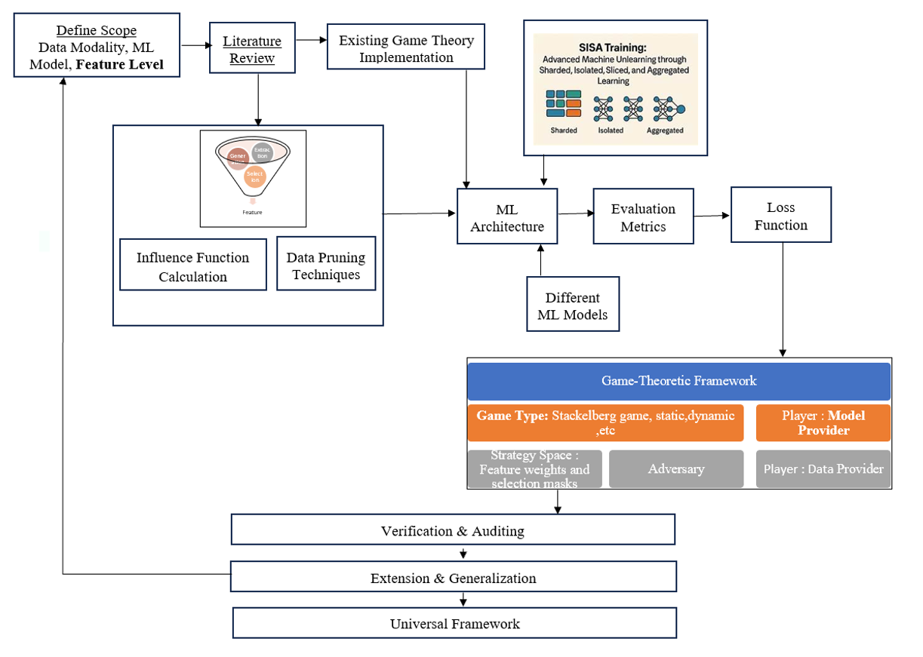
Figure 6 : Feature level Machine Unlearning

5.2.2 Objective-2
Systematically analyse the robustness of the game-theoretic unlearning mechanism under different attack models.
In limited scope work has been done on similar lines in Game-Theoretic Machine Unlearning: Mitigating Extra Privacy Leakage [21] , learning and exploring in that direction this objective this focusses on including different attack models in the machine unlearning framework. Further it will expand on the scope of research to include other ML models as well. In game theory framework , utility of bias also is planned to be explored in addition to privacy.
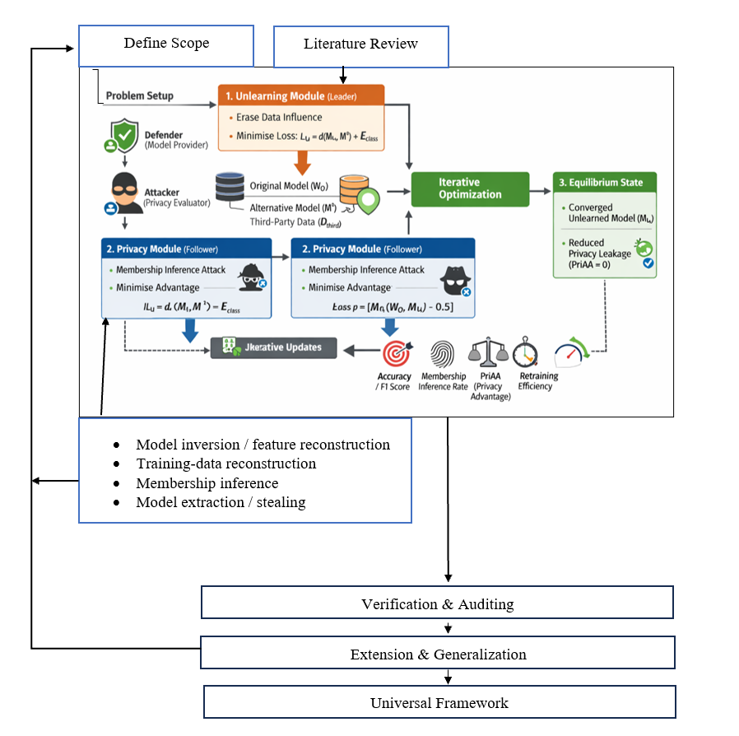
Figure 7 : Game-Theoretic Unlearning under Different Attack Models
Figure 7 below depicts the methodology for objective 2:
  - Already Implemented for
    - Utility module: loss = model distance + classification error.
    - Privacy module: loss = attacker’s advantage (membership inference success probability).
    - Game model : Stackelberg
    - This study will first reproduce their methodology and results to establish a validated baseline. Following replication, the research will critically analyse limitations (e.g., reliance on membership inference only, scalability to larger models, sensitivity to dataset choice). Building on this review, the work will then explore extensions such as :
• Incorporating broader attack models (attribute inference, reconstruction, poisoning).
• Adapting the framework to federated and dynamic unlearning settings.
• Extending utility functions to include fairness and transparency metrics.
• Scaling the approach to large language models (LLMs) and high-parameter deep networks.

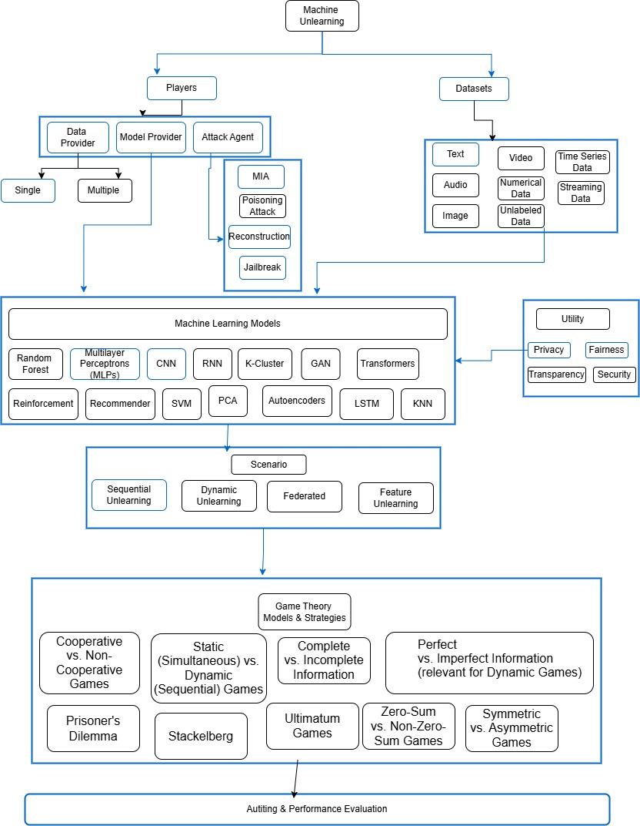
Figure 8 ML GT Space for MIA via Backdoor
Figure 8 shows the scenario space we are supposed to traverse in the universe of Machine Unlearning and Game Theory. The blocks highlighted in blue colour marks the tentative scope for this objective.

5.2.3 Objective-3
Develop adaptive game-theoretic strategies for machine unlearning in evolving data ecosystems.
Figure 9 depicts the flow of research methodology for objective 3 :
Based on the research done in objective 1 and objective 2, some generalized principles would have been established, the goal is to incorporate different data systems available in machine unlearning space and simulate analysis how these generalized principles scaled to different data ecosystems.
By data ecosystem , it is meant the different scenarios which exist with respect to data, for example listing some patterns here:
- Streaming data
- Multiplayer Data Sharing
- Federated Settings for data
- Bulk data unlearning requests
These are some of the examples , further not just building on existing generalized principles, this objective also aims at study underexplored areas.
The methodology takes input from universal framework as well as has scope to include new scenarios which are not covered in objective 1 & 2.
Figure 9 : Data Ecosystem Based Flow

6.Expected Outcome
- Develop strategic frameworks for Machine Unlearning- Define agents, strategies, and payoff functions – Efficient & Effective
- Enable model providers to optimize compliance and performance
- Empowering Data Providers - Provide users with transparency and control, Help assess effectiveness of unlearning services
- Foster trust and responsible data sharing

7.Importance of Proposed Research
- Anchors the “Right to be Forgotten” in machine learning systems.
- Ensures compliance with global data protection laws (GDPR, CCPA, DPDP Act).
- Reduces conflicts and ensures justice by giving individuals control over their data.
- Supports sustainable AI deployment in production environments.

8.Research Time Plan
Table 3 : Research Plan Schedule
Research Activity |  | Time ( from Registration) in Months
 |  | 06 | 12 | 18 | 24 | 30 | 36 | 42 | 48 | 54
Course Work
Literature Survey
Objective 1
Objective 2
Objective 3
DAC presentation and registration renewal
Conference presentations |  |  |  |  |  | C |  | C
Journal Publications |  |  |  |  |  |  | J |  | J
Preparation of Final Thesis
Synopsis presentation
Submission of Thesis

9.Pilot study
The pilot study was undertaken to understand the feasibility of Machine Unlearning with Game Theory frameworks. Since, the implementation of both are very few and not readily available. We tried to focus our pilot study in understanding existing machine unlearning and how it has potential for strategic interactions. Also, for better understanding of game theory for implementation purposes we studied code implementation. We are also tried to gain information on the datasets and experimental setups done, also we tried to analyze how game theory framework can be applied to machine unlearning by understanding and implementing existing papers.

9.1 Pilot Study: Part 1 (Machine Unlearning)
The SISA model training [15] is very useful technique which helps to understand the basic principles of machine unlearning ,
It’s basic idea which is very simple, but it also help us understand the overall challenges possible in exact machine unlearning in very simplistic way, we were able to implement it while we observed some code fixes were necessary. I see potential of game theory based strategic interactions in SISA , I propose to explore and implement feature based game theory framework interactions and also analyze which game theory frameworks could be applicable.

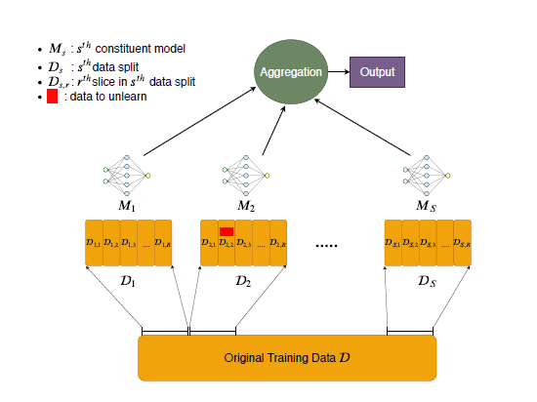

Figure 10 : SISA Training Architecture [15]
Figure 10 depicts :
SISA training: the data is split in to shards (further can be sliced), each shard is trained in isolation and weights are saved at each shard level, finally ensemble learning aggregates the final outcome.

- Methodology : Sharded, Isolated, Sliced, Aggregated training for efficient unlearning
- Tools/datasets : Python, TensorFlow, Purchase dataset
- Key Findings :
  - Accuracy trade-off increases with complex tasks and higher shard counts.
  - Requires additional storage for slicing checkpoints.
  - Performance gains diminish if unlearning requests exceed ~3× number of shards.
  - Stronger guarantees than differential privacy, but still challenging for very large foundational models.
- Relevance : Establishes a scalable baseline for machine unlearning strategies, focuses on data sample unlearning, opportunity to extend to data manipulation strategy at feature level unlearning.
  - The pilot study confirms the feasibility of integrating Game Theory into Machine Unlearning.
  - Current unlearning methods focus on efficiency but ignore strategic interactions (e.g., balancing user privacy demands vs. provider resource costs).
  - Game Theory can formalize these negotiations, ensuring fairness and incentive compatibility.
Results
The SISA training successfully reduced the computational cost, further gains can be achieved if there is more information on incoiming unlearning requests distribution pattern, sharding can be adapted to distributional pattern and makor gains can be achieved in real time.
However some trade-offs needs to be considered , same has been explained with the help of below diagrams:
  - Accuracy vs Requests (one line per shard count)
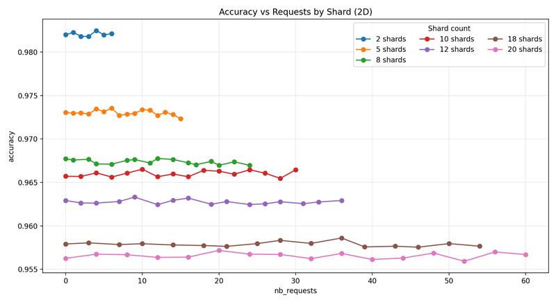
Figure 11 : Accuracy vs Requests (one line per shard count)
Figure 11 shows Accuracy is primarily separated by shard count (higher at low S; lower at high S). Within each shard, accuracy is relatively stable across requests. It also shows that accuracy drops as shard count increases and this is because SISA isolates training per shard; each constituent sees less data, which can create weak learners and reduce aggregate accuracy as S grows—especially for more complex tasks. Your plots show a clean monotonic decline of accuracy with S.

  - 2D Facets: Retraining Time vs Requests
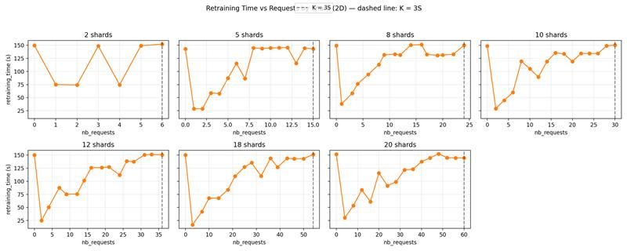
Figure 12 : Retraining Time vs Requests
Figure 12 shows that retraining gets cheaper as shards increase For one request, retraining is confined to the affected shard; expected cost scales with shard size (~N/S). Hence higher S reduces retraining cost/time—exactly what the time curves show.

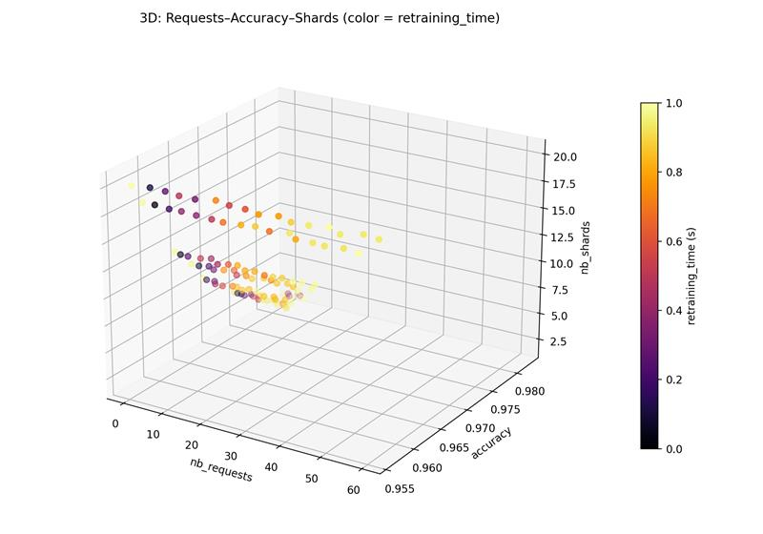
  - Requests × Accuracy × Shards; color = Retraining Time
Figure 13 : Retraining Time vs Requests vs Accuracy
Figure 13 shows Lower shards leads to higher accuracy but often longer retraining time (brighter colours). Higher shards leads to lower accuracy but retraining tends to cluster lower/steadier. This is the central accuracy - time trade-off expected from SISA sharding.
The research also highlights the Threshold on number of requests (K) vs shards (S) The paper notes sharding’s benefits are most pronounced while K is not too large relative to S, with a practical boundary often discussed around K ≲ 3S; beyond that, overall savings degrade toward the baseline. The dashed lines at K=3S in the facet chart make that region explicit for your data.
At inference, SISA aggregates shard-models (e.g., majority vote or averaging prediction vectors). On simple tasks, strategy changes matter little; on complex tasks, averaging prediction vectors helps recover accuracy , consistent with the paper’s observations. Your accuracy separation by S is fully consistent with this aggregation-driven ensemble behaviour.

9.2 Pilot Study: Part 2 (Membership Inference via Backdooring)
The paper is based on MIA, understanding the factors leading to successful MIA and possible mitigation methods can actually help the players in choosing the right strategy in the game. It is relevant for objective 2 to deep dive on designing strategy game to reduce chances of successful MIA in existing Machine Unlearning algorithms including SISA and others. And also relevant as base work to explore other attack models.

- Problem Definition
  - Goal: Efficient unlearning without retraining.
  - Challenge: Balance between utility (model accuracy) and privacy (prevent leakage via membership inference).
- Threat Model
  - Attacker: Black-box access to original and unlearned models; attempts membership inference.
  - Defender (Model Provider): White-box access; aims to erase data influence and reduce leakage.
  - ASR is defined as follows:
ASR = # Successful attacks/All attacks
Attack success Rate
- Game-Theoretic Framework
  - Modelled as a Stackelberg game (leader–follower).
  - Leader: Unlearning module (removes data, minimizes loss = model distance + classification error).
  - Follower: Privacy module (responds to leader’s strategy, minimizes attacker’s privacy advantage).
- Unlearning Module
  - Uses an alternative retrained model (on subset of retain data).
  - Loss function = distance (original vs. alternative model outputs) + classification error.
  - Updates parameters iteratively to erase target data influence.
- Privacy Module
  - Trains a membership inference attack model.
  - Loss function = privacy attack advantage (difference from random guess, ideally → 0.5).
  - Adjusts parameters to reduce leakage risk.
- Equilibrium
  - Iterative updates between modules.
  - Converges to an unlearned model statistically indistinguishable from retrained one, with reduced privacy leakage.

9.3 Pilot Study: Part 3 (Game Theory)
For real world application going beyond theory, it is required to implement our theoretical models and derive conclusion – MLPro-GT helps us by giving a reference to use and build on its existing game theory framework, though it’s existing use case has been limited to basic cases and not complex, it can be stepping stone to implement our logic and expand on its existing implementation.

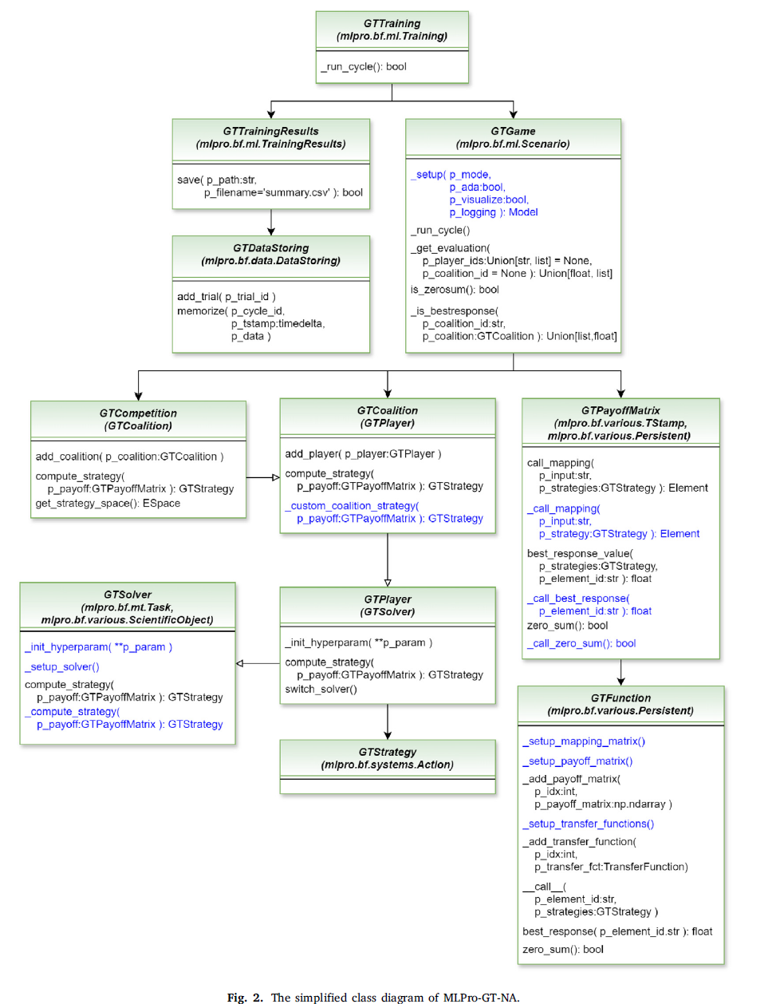
Figure 14 : The simplified class diagram of MLPro-GT-NA
Figure 14 shows the class level implementation of MLPro-GT, it shows structured way to create player, define strategies, form coalitions etc.

10.Details of Expenses and Source of Funding
The most suitable concepts for research funding will be studied and communicated.

11.Course Work Details
Table 4 : Course Work Details suggested by DAC with credits
S. No. | Title of Course Work | Credits | Status | Grade
1 | Advanced Research Methodology (ARM) | 4 | In Progress (IP) | -
2 | Research and Publication Ethics (RPE) | 2 | Completed | A
3 | Machine Learning | 3 | To Be Taken (TBT) in July 2026;  NPTEL Course | -
4 | Responsible and Safe AI Systems | 3 | To Be Taken (TBT) in July 2026; NPTEL Course | -
5 | Game Theory | 2 | To Be Taken (TBT) in July 2026;  NPTEL Course | -

2.Similarity Check Report
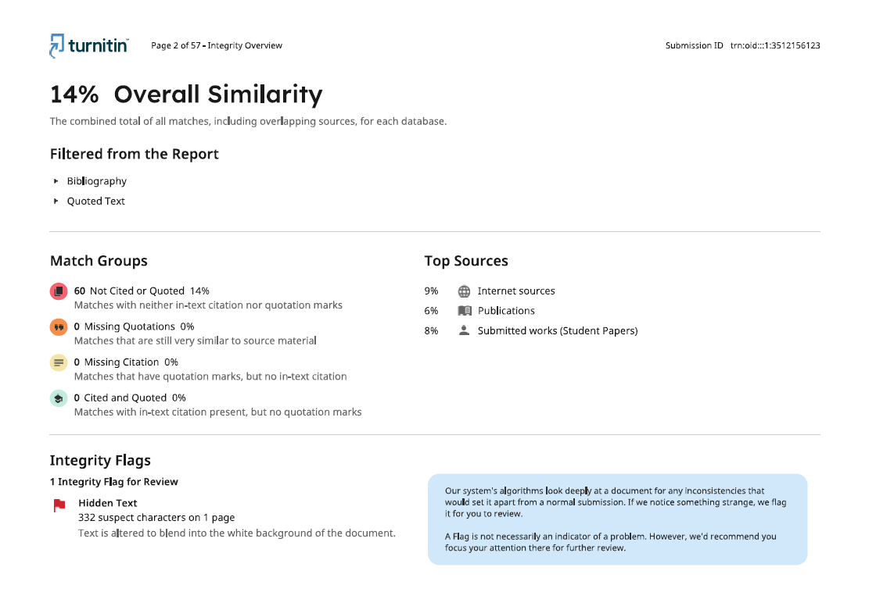

13. References
[1] | S. Wesselby, "Responsible AI: Principles, Practices, and Applications. How to implement AI responsibly," Udemy course. [Online]. Available: https://www.udemy.com/course/responsible-ai-principles-practices-and-applications/. [Accessed: Dec. 29, 2025].
[2] | Wang, Z. Tian, C. Zhang, and S. Yu, “Machine Unlearning: A Comprehensive Survey,” arXiv preprint arXiv:2405.07406v2, Jul. 25, 2024. [Online]. Available: https://arxiv.org/abs/2405.07406. [Accessed: Mar. 10, 2025]
[3] | H. Xu, T. Zhu, L. Zhang, W. Zhou, and P. S. Yu, “Machine Unlearning: A Survey,” ACM Comput. Surv., vol. 56, no. 1, Art. no. 9, Aug. 2023. doi: 10.1145/3603620. [Online]. Available: https://doi.org/10.1145/3603620. [Accessed: Jan. 10,2025].
[4] | S. Yuwono, D. Arend, and A. Schwung, “MLPro-GT—game theory and dynamic games modeling in Python,” SoftwareX, vol. 28, p. 101956, Nov. 2024. [Online]. Available: https://doi.org/10.1016/j.softx.2024.101956 (doi.org in Bing). [Accessed Jun. 4, 2024]
[5] | D. Arend, S. Yuwono, M. R. Diprasetya, and A. Schwung, “MLPro 1.0 — Standardized reinforcement learning and game theory in Python,” Machine Learning with Applications, vol. 9, p. 100341, May 2022. [Online]. Available: https://doi.org/10.1016/j.mlwa.2022.100341 (doi.org in Bing). [Accessed Jun. 4, 2026]
[6] | X. Liang, Z. Yan, R. H. Deng, and Q. Zheng, “Investigating the Adoption of Hybrid Encrypted Cloud Data Deduplication With Game Theory,” IEEE Trans. Parallel Distrib. Syst., vol. 32, no. 3, pp. 587–603, Mar. 2021. [Online]. Available: https://doi.org/10.1109/TPDS.2020.3028685. [Accessed Mar. 14, 2025]
[7] | L. Cui, Y. Qu, M. R. Nosouhi, S. Yu, J.-W. Niu, and G. Xie, “Improving Data Utility Through Game Theory in Personalized Differential Privacy,” J. Comput. Sci. & Technol., vol. 34, no. 2, pp. 272–286, Mar. 2019. [Online]. Available: https://doi.org/10.1007/s11390-019-1910-3 (doi.org in Bing). [Accessed Mar. 12, 2025]
[8] | The Guardian, “Cambridge Analytica and Facebook data scandal,” The Guardian, 2018. [Online]. Available: https://www.theguardian.com/news/series/cambridge-analytica-files (theguardian.com in Bing). [Accessed: Mar. 19, 2026]
[9] | Harvard Business School Working Knowledge (reporting on media coverage), “Gender Bias Complaints against Apple Card Signal a Dark Side to Fintech,” Harvard Business School, Nov. 2019. [Online]. Available: https://hbswk.hbs.edu/item/gender-bias-complaints-against-apple-card-signal-a-dark-side-to-fintech (hbswk.hbs.edu in Bing). [Accessed: Mar. 19, 2025]
[10] | J. Dastin, “Amazon scraps secret AI recruiting tool that showed bias against women,” Reuters, Oct. 2018. [Online]. Available: https://www.reuters.com/article/us-amazon-com-jobs-automation-insight-idUSKCN1MK08G (reuters.com in Bing). [Accessed: Mar. 19, 2026]
[11] | K. Hill, “The Secretive Company That Might End Privacy as We Know It,” The New York Times (reporting on Clearview AI), Jan. 2020. [Online]. Available: https://www.nytimes.com/2020/01/18/technology/clearview-privacy-facial-recognition.html (nytimes.com in Bing). [Accessed: Mar. 19, 2026].
[12] | K. Wagstaff, “How Target Knew a High School Girl Was Pregnant Before Her Parents Did,” Time, Feb. 2012. [Online]. Available: https://time.com/36703/how-target-knew-a-high-school-girl-was-pregnant-before-her-parents-did/ (time.com in Bing). [Accessed: Mar. 19, 2026]
[13] | Gartner, “Gartner Predicts 40% of AI Data Breaches Will Arise from Cross-Border GenAI Misuse by 2027,” Gartner Press Release, Feb. 17, 2025. [Online]. Available: https://www.gartner.com/en/newsroom/press-releases/2025-02-17-gartner-predicts-40-percent-of-ai-data-breaches-will-arise-from-cross-border-genai-misuse (gartner.com in Bing). [Accessed: Mar. 19, 2026]
[14] | A. Mantelero, “The EU proposal for a general data protection regulation and the roots of the ’right to be forgotten’,” Comput. Law Secur. Rev., vol. 29, no. 3, pp. 229–235, 2013. [Online]. Available: http://www.sciencedirect.com/science/article/pii/S0267364913000289 (sciencedirect.com in Bing). [Accessed: Feb. 2, 2025]
[15] | Canada, “Personal Information Protection and Electronic Documents Act, S.C. 2000, c. 5,” 2000. [Online]. Available: https://canlii.ca/t/56gxt. [Accessed: Nov. 27, 2025]
[16] | Government of India, “Digital Personal Data Protection Act, 2023.” [Online]. Available: https://www.meity.gov.in/static/uploads/2024/06/2bf1f0e9f04e6fb4f8fef35e82c42aa5.pdf. [Accessed: Jan. 5, 2025]
[17] | Office of the Privacy Commissioner of Canada, “Announcement: Privacy commissioner seeks federal court determination on key issue for Canadians’ online reputation.” [Online]. Available: https://www.priv.gc.ca/en/opc-news/news-and-announcements/ (priv.gc.ca in Bing). [Accessed: Dec. 28, 2025].
[18] | H. Hu, Z. Salcic, G. Dobbie, J. Chen, L. Sun, and X. Zhang, “Membership Inference via Backdooring,” arXiv preprint arXiv:2206.04823, Jun. 2022. [Online]. Available: https://arxiv.org/abs/2206.04823. [Accessed: Mar. 19, 2026].
[19] | L. Bourtoule, V. Chandrasekaran, C. A. Choquette-Choo, H. Jia, A. Travers, B. Zhang, D. Lie, and N. Papernot, “Machine unlearning,” Proc. IEEE Symp. Secur. Priv. (SP), 2021. [Online]. Available: https://www.ieee.org. [Accessed Dec. 27, 2025]
[20] | C. Guo, T. Goldstein, A. Hannun, and L. Van Der Maaten, “Certified Data Removal from Machine Learning Models,” in Proc. 37th Int. Conf. Mach. Learn., vol. 119, H. D. III and A. Singh, Eds., Jul. 13–18, 2020, pp. 3832–3842. [Online]. Available: https://proceedings.mlr.press/v119/guo20c.html. [Accessed Mar. 4, 2025]
[21] | H. Liu, T. Zhu, L. Zhang, and P. Xiong, “Game-Theoretic Machine Unlearning: Mitigating Extra Privacy Leakage,” Journal of LaTeX Class Files, vol. 14, no. 8, Aug. 2021. [Online]. Available: http://www.example-journal.org. [Accessed Dec. 28, 2025]
[22] | Y. Cao and J. Yang, “Towards making systems forget with machine unlearning,” Proc. IEEE Symp. Secur. Priv., 2015, pp. 463–480. [Online]. Available: https://doi.org/10.1109/SP.2015.35. [Accessed Dec. 30, 2025]
[23] | D. Ye, T. Zhu, C. Zhu, D. Wang, K. Gao, Z. Shi, S. Shen, W. Zhou, and M. Xue, “Reinforcement Unlearning,” arXiv preprint arXiv:2312.15910, 2024. [Online]. Available: https://arxiv.org/abs/2312.15910. [Accessed Sep. 2, 2025]
[24] | X. Ding, H. Fang, Z. Zhang, K.-K. R. Choo, and H. Jin, “Privacy-Preserving Feature Extraction via Adversarial Training,” IEEE Trans. Knowl. Data Eng., vol. 34, no. 4, pp. 1967–1979, 1 Apr. 2022. [Online]. Available: https://doi.org/10.1109/TKDE.2020.2997604. [Accessed Aug. 6, 2026]
[25] | B. Zhang, et al., “Sample-Centric Feature Generation for Semi-Supervised Few-Shot Learning,” IEEE Trans. Image Process., vol. 31, pp. 2309–2320, 2022. [Online]. Available: https://doi.org/10.1109/TIP.2022.3154938 (doi.org in Bing). [Accessed Feb. 7, 2026]
[26] | J. Zhu, Y. Liu, C. Wen, and X. Wu, “DGDFS: Dependence Guided Discriminative Feature Selection for Predicting Adverse Drug-Drug Interaction,” IEEE Trans. Knowl. Data Eng., vol. 34, no. 1, pp. 271–285, 1 Jan. 2022. [Online]. Available: https://doi.org/10.1109/TKDE.2020.2978055 (doi.org in Bing). [Accessed Apr. 9, 2026]
[27] | Y. Zhao, et al., “Exploring Federated Unlearning: Review, Comparison, and Insights,” IEEE Network. [Online]. Available: https://doi.org/10.1109/MNET.2025.3571462. [Accessed Mar. 3, 2025]
[28] | L. de la Torre, “A guide to the California Consumer Privacy Act of 2018,” SSRN. [Online]. Available: https://papers.ssrn.com/sol3/papers.cfm?abstract_id=3275571 (papers.ssrn.com in Bing). [Accessed: Dec. 30, 2025]
[29] | S. Leonardos and G. Piliouras, “Exploration-Exploitation in Multi-Agent Learning: Catastrophe Theory Meets Game Theory,” arXiv:2012.03083v2 [cs.GT], Dec. 15, 2020. [Online serial]. Available: https://arxiv.org/abs/2012.03083. [Accessed Jan. 12, 2025]
[30] | J. Geng, Q. Li, H. Woisetschlaeger, Z. Chen, F. Cai, Y. Wang, P. Nakov, H.-A. Jacobsen, and F. Karray, “A Comprehensive Survey of Machine Unlearning Techniques for Large Language Models,” arXiv preprint arXiv:2503.01854, 2025. [Online]. Available: https://doi.org/10.48550/arXiv.2503.01854. [Accessed Aug. 5, 2025]

